PipeLine Utilities A-3
Introduction A-3
PipeLine’s File Utilities A-3
Program Properties A-3
Exiting PipeLine A-4
PipeLine’s Consumption Utilities A-4
Importing Data A-4
Reconciling Imported Data A-14
Reconciling PipeLine Data A-14
PipeLine’s Tools Utilities A-15
Changing the Display Language A-17
Accessing the Summary Module A-18
Compacting the PipeLine Database A-18
Importing NEWVERN Data A-18
Choose PDF Printer A-18
PipeLine’s Help Utility A-19
PipeLine’s About Feature A-19

Pipeline utitlies
Figure A-1—PipeLine Menu Bar A-3
Figure A-2—File options A-3
Figure A-3—Program properties A-3
Figure A-4—Consumption options A-4
Figure A-5—Import Consumption Data window A-13
Figure A-6—Import Reconciliation window A-13
Figure A-7—Product association options A-14
Figure A-8—Tools options A-15
Figure A-9—Language options A-18
Figure A-10—Select PDF Writer from list A-19
Figure A-11—Help options A-19
Figure A-12—PipeLine’s About window A-19

PipeLine Utilities

Introduction
PipeLine’s collection of utilities can be accessed from the Menu Bar. These utilities give you access to features that can enhance PipeLine’s usefulness. Sample Figure A-1 shows the PipeLine Menu Bar.
Figure A-1—PipeLine Menu Bar

PipeLine’s File Utilities
The File option of the PipeLine Menu Bar enables you to add, open, copy, and close program data files. It also enables you to display the properties of the current program and to exit PipeLine.
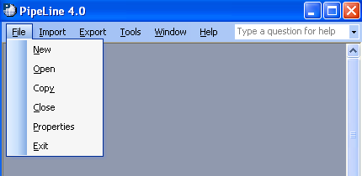
Figure A-2—File options

The first four options of the File option’s drop-down menu (New, Open, Copy, and Close) are explained in section 3 of this guide.

Program Properties
The Properties option displays basic information about the program file you are currently using.

To display the properties of the current program—
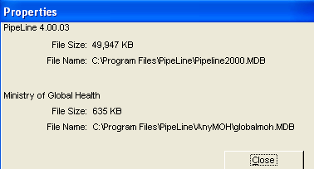
Figure A-3—Program properties

- Click on the File Menu Bar option.

- Click on the Properties option.

PipeLine displays the Properties window (see Figure A-3).

- Click on the Close button to close the Properties window.

Exiting PipeLine
You can exit PipeLine at any time.

To exit PipeLine—

- Click on the File Menu Bar option.

- Click on the Exit option.

PipeLine’s Import Utilities
The Import option of the Menu Bar enables you to import product, consumption, and shipment data.
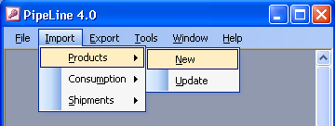

Figure A-4—Import Product options Importing Product Data
PipeLine allows you to either import new product data or update product data previously imported. Figure A-4 shows the selections available through the drop-down menu.

Import New Product Data
To import new products generated by other procurement systems.—

- Click on the Import Menu Bar option.

- Click on the Product option.

- Click on the New option.

The Import Product List window is displayed (see Figure A-5—Import Product List window).
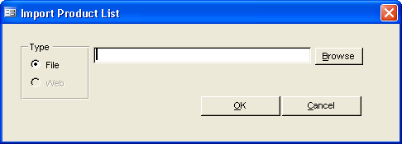
Figure A-5—Import Product List window
!! | Inside the Type box, be sure that the File radio button is selected. The functionality for the Web option is currently not available.

- Type the location of the product file you need to import, and click on the OK button.

PipeLine displays a warning message if the XML file is not valid for this Country Program.
 | If you are not sure where the file is located, use the Browse button. Click on the Browse button, and use Windows Explorer to locate the file you need. Click on the file, and Click Open.
 | Never import a file from the A:\ drive. Move the data from the A:\ drive to your hard disk, then use the Import Option to select the data.
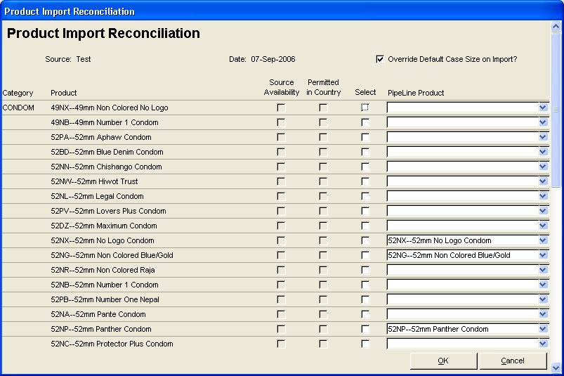
Figure A-6—Product Import Reconciliation window After validating the file, PipeLine displays the Product Import Reconciliation window (see Figure A-6—Product Import Reconciliation window).

Reconciling Imported Product Data
The Product Import Reconciliation screen shows a list of all potential products to be imported. The Source field is filled with the source of the import data.

For example: If the data was imported from SCMS, the name is displayed in the Source field in the Product Import Reconciliation window (see Figure A-6—Product Import Reconciliation window).

The Date field contains the date the import file was created. The Override Default Case Size on Import? field identifies if the import values will overwrite the default case size in the database.

- Deselect “Override Default Case Size in import?” if you do not want the default Case Size overwritten with what is in the import file.

The Category column displays the category for the product in the import file, and the Product column displays the Product Code and Product Name for the product values in the import file. The next two columns are marked with a check only if a particular product in the import file is available from the source of the import file and if it is permitted in the country. The final two columns are used to select a product to be imported, and to map products to existing PipeLine products, if necessary.

To select a product for import—
 | Products that are available from the source and are permitted in the country will automatically be selected for import. Also, all products with a code that matches a PipeLine product will automatically be mapped; the mapping cannot be modified.

- Click on the Select column for each product you would like to import into PipeLine.

To associate a product being imported with existing PipeLine products—

- Click on the arrow next to a blank data field, and select the PipeLine product that corresponds to the imported product.

- Repeat the process for each product that needs to be associated with an existing PipeLine product.

Mapping a new product to an existing PipeLine product will not import it. You must also check the Select column in the new product’s row.
After you select the products to be imported and associate the product where applicable—

- Click on the OK button to complete the import.

After the selected products are imported into PipeLine, the Import Report will be displayed. This report shows all the products that were imported, and also lists any errors for the products that were selected but not imported. Using the toolbar, you can export the report to Word, Excel, or PDF.
!! | The system does not save these reports, so is strongly recommended that you either export or print the report (before closing it).

After the report is closed, you will return to the main screen and will be able to view the newly imported products in the Product form.

Update Product Data
To update information, including cost data, for products previously imported from other procurement systems.—

- Click on the Import Menu Bar option.

- Click on the Product option.

- Click on the Update option.

The Update Product List window is displayed (see Figure A-7).
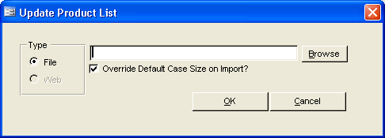
Figure A-7—Update Product List window
!! | Inside the Type box, be sure that the File radio button is selected. The functionality for the Web option is currently not available.
- Type the location of the product file you need to import, and click on the OK button.

- Deselect “Override Default Case Size in import?” if you do not want the default Case Size overwritten with what is in the import file.
If you are not sure where the file is located, use the Browse button. Click on the Browse button, and use Windows Explorer to locate the file you need. Click on the file, and click Open.

PipeLine displays a warning message if the XML file is not valid for this Country Program.

Never import a file from the A:\ drive. Move the data from the A:\ drive to your hard disk, then use the Import Option to select the data.
PipeLine will automatically update information for all corresponding products. After the products are updated into PipeLine, the Import Report will be displayed. This report shows all the products that were updated. Using the toolbar, you can export the report to Word, Excel, or PDF.
!! | The system does not save these reports, so is strongly recommended that you either export or print the report (before closing it).
After the report is closed, you will return to the main screen, and will be able to view the newly updated products in the Product form.

Importing Consumption Data
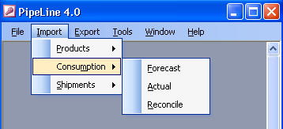
Figure A-8—Import Consumption options
PipeLine enables you to import forecast and actual consumption data generated by other logistics management systems (see Figure A-8).

Import Forecast Consumption Data
To import forecast consumption data.—

- Click on the Import Menu Bar option.

- Click on the Consumption option.

- Click on the Forecast option.

PipeLine displays the Import Forecast Data window so you can select the data files to import (see Figure A-9).
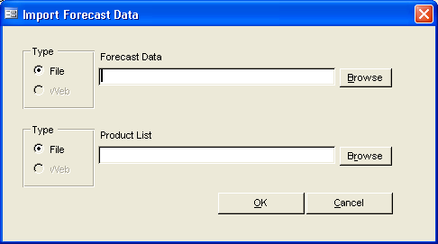
Figure A-9—Import Forecast Data window

- Type the location of the Forecast Data file you need to import.
!! | Inside both Type boxes be sure that the File radio button is selected. The functionality for the Web option is currently not available.

- Type the location of the Product List file you need to import.
If you are not sure where the forecast data file is located, use the Browse button. Click on the Browse button, and use Windows Explorer to locate the file you need. Click on the file and click Open.

- Click OK.
If you are not sure where the product list file is located, use the Browse button. Click on the Browse button, and use Windows Explorer to locate the file you need. Click on the file and click Open.

PipeLine displays a warning message if the XML files are not valid for this Country Program.

Never import a file from the A:\ drive. Move the data from the A:\ drive to your hard disk, then use the Import Option to select the data.
After validating the file, PipeLine displays the Forecast Data Import Reconciliation window (see Figure A-10).
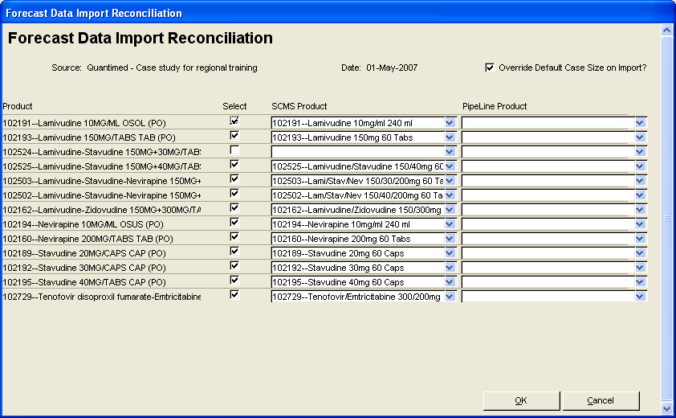
Figure A-10—Forecast Data Import Reconciliation window

Reconciling Imported Forecast Consumption Data
The Forecast Data Import Reconciliation screen shows a list of all potential forecast data and products to be imported. The Source field displays the source of the import data.

For example: If the data were imported from SCMS, the name is displayed in the Source field on the Forecast Data Import Reconciliation window (see Figure A-6—Product Import Reconciliation window).

The Date field displays the date on which the import file was created. The Override Default Case Size on Import? field identifies if the import values will overwrite the default case size in the database.

- Deselect “Override Default Case Size in import?” if you do not want the default Case Size overwritten with what is in the import file.

The Product column displays the Product Code and Product Name for the products in the imported forecast data file. The Select field is used to select which product forecast consumption data will be imported. The final two columns are used to map forecast data file products to the product displayed in the selected product list and to existing PipeLine products, if necessary.

To select consumption data for import—
 | All products that match a product in either the product list file or in PipeLine will automatically be mapped; the mapping cannot be modified.

- Click on the Select column for each product whose consumption data you would like to import into PipeLine.

To associate consumption data to be imported with product in the Product List—

- Click on the arrow next to a data field in the SCMS Product column, and select the product that corresponds to the imported consumption data.

- Repeat the process for each product that needs to be associated with a product in the Product List.

Mapping consumption data to a product in the Product List will not import it. You must also check the Select column in the corresponding row to import it.
To associate a product being imported with existing PipeLine products—

- Click on the arrow next to a blank data field, and select the PipeLine product that corresponds to the imported consumption data.

- Repeat the process for each product that needs to be associated with an existing PipeLine product.

Mapping a new product to an existing PipeLine product will not necessarily import it. You must also check the Select column in the corresponding row to import it.
After you select the products to be imported and associate the products where applicable—

- Click on the OK button to complete the import.

After the selected consumption data is imported into PipeLine, the Import Report will be displayed. This report shows all the products which were imported with associated forecast consumption data, and also lists any errors for the products that were selected but not imported. Using the toolbar, you can export the report to Word, Excel, or PDF.
 | If you check the Select column for a product and then leave both the SCMS Product and PipeLine Product columns blank, a brand new product in PipeLine will be created with this product’s forecast consumption data.  If you check the Select column for a product and then select a SCMS Product but not a PipeLine Product, the SCMS Product will be imported into PipeLine and all corresponding forecast consumption data will be associated with this SCMS Product’s name.  If you check the Select column for a product and then select a SCMS Product and a PipeLine Product, the SCMS Product will be imported into PipeLine replacing the existing PipeLine Product and all corresponding forecast consumption data will be associated with this new SCMS Product’s name.  If you check the Select column for a product and then select a PipeLine Product but not a SCMS Product, the forecast consumption data will be associated with this PipeLine Product’s name.
!! | The system does not save these reports, so is strongly recommended that you either export or print the report (before closing it).

After the report is closed, you will return to the main screen, and will be able to view the newly imported products and consumption data.

Import Actual Consumption Data
To import actual consumption data—

- Click on the Import Menu Bar option.

- Click on the Consumption option.

- Click on the Actual option.
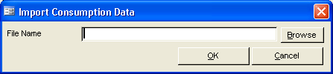
Figure A-11—Import Consumption Data window
The Import Consumption Data window is displayed (see Figure A-11).

- Type the location of the file you need to import, and click the OK button.
If you are not sure where the file is located, use the Browse button. Click on the Browse button, and use Windows Explorer to locate the file you need. Click on the file, and click Open.

PipeLine displays a confirmation message, so you can confirm that the selected data can be imported.
Never import a file from the A:\ drive. Move the data from the A:\ drive to your hard disk, then use the Import Option to select the data.

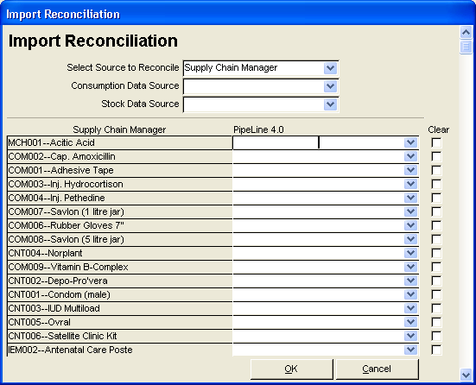
Figure A-12—Import Reconciliation window After you locate and import the file, PipeLine displays the Import Reconciliation window
(see Figure A-12).

Reconciling Imported Data
The imported actual consumption data can be reconciled.

The Source to Reconcile field displays the source of the import data.

For example: If the data were imported from a tool such as Supply Chain Manager, the name of the tool is displayed in the Select Source To Reconcile field on the Import Reconciliation window (see Figure A-12).

If the entry in the Select Source to Reconcile field does not reflect the imported data’s origin—

- Click on the arrow next to the Select Source to Reconcile field, and select the import data’s source from the pull-down menu.

The Consumption Data Source field identifies the source of consumption data (e.g., reports, estimates, etc.).

- Click on the arrow next to the Consumption Data Source field and select the consumption data source from the pull-down menu.

The Stock Data Source field identifies the source of stock level data (e.g., physical inventories, reports, etc.).

- Click on the arrow next to the Stock Data Source field, and select the stock data source from the pull-down menu.

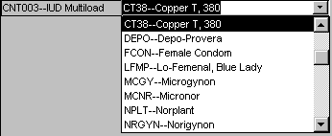
Figure A-13—Product association options After you select the appropriate data sources, you must associate the products of the imported data set with products in PipeLine.

For example: Figure A-13 shows that the imported product CNT003—IUD Multiload is associated with PipeLine product CT38—Copper T, 380.

To associate imported products with PipeLine products—

- Click on the arrow next to a blank data field, and select the PipeLine product that corresponds to the imported product.

- Repeat the process until all imported products are associated with corresponding PipeLine products.

After you associate all products—

- Click on the OK button to reconcile the data.

Reconcile Consumption Data
The Reconcile option of the Consumption Menu Bar option performs the same operation as the reconcile step of the Import Actual Consumption Data function. To reconcile actual consumption data—

- Click on the Import Menu Bar option.

- Click on the Consumption option.

- Click on the Reconcile option.

See Reconciling Imported Data on page 14 for instructions on reconciling PipeLine data.

Importing Shipment Data
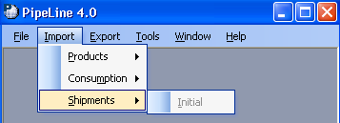
Figure A-14—Import Shipment options
The Shipment Import option of the Import Menu Bar option becomes available after you create and save a new program. This option enables you to import data from other commodity management systems.
 | You will only be able to use this option if you have access to an exported data file, and the program you are currently working with does not have any USAID shipments associated with it.  This option can only be used once per program.
To import shipment data—

- Click on the Import Menu Bar option.

- Click on the Shipment option.

- Click on the Initial option.

A window is displayed, showing the file(s) available for import. Files are identified by the .d extension (e.g., woo1120.d, 0201020.d, 03021r00.d, etc.).

- Click on the file you need to import.

- Click on the Open button to import the file.

A window is displayed, asking if the file you selected contains SCMS shipments.

- Click Yes if the file being imported contains SCMS shipments, otherwise click No.

The selected data is imported into PipeLine.

PipeLine’s Export Utilities
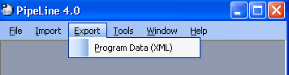
Figure A-15—Export options
The Export option of the Menu Bar lets you export program data (see Figure A-15).

Exporting Program Data
To export program data—

- Click on the Export Menu Bar option.

- Click on the Program Data (XML) option.

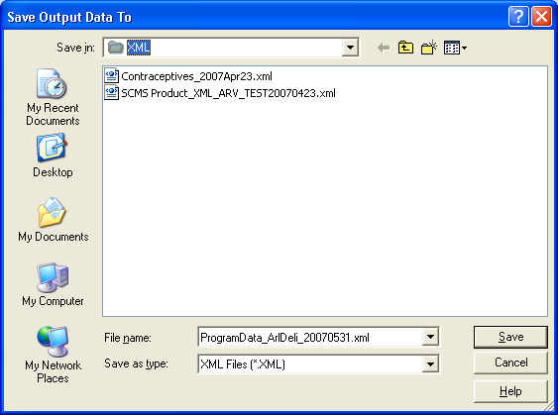
Figure A-16—Save Output Data To window PipeLine displays the Save Output Data To window so you can save the current program data as an XML file (see Figure A-16). The default file name is created by PipeLine based on the Program Code and the date.

- Click on the Save button to accept the default file name.
Or, type a new file name and click on the Save button.
If Export -> Program Data (XML) is selected by accident, you can go back to the previous screen by clicking the Cancel button on the Save Output Data To screen.
Never save the data to your A:\ drive.

PipeLine displays the Program Data Export (XML) window as notification that the export of program data was successfully completed. This window shows the location of the newly created file.

- Click OK.

Your previous location in PipeLine is redisplayed after the data is saved.
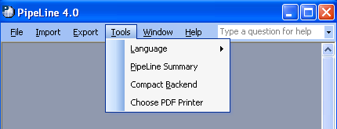

Figure A-17—Tools options PipeLine’s Tools Utilities
The PipeLine Tools Menu Bar option lets you change PipeLine’s display language, access the PipeLine Summary module, compact the PipeLine database, and choose a PDF printer.

Changing the Display Language
PipeLine supports English, Spanish, French, Arabic, and Portuguese. To change the display language at any time, use the Language option of the Tools Menu Bar option. This temporary change remains in effect for the duration of the session.

 | Only PipeLine’s screens, buttons, and messages are converted to the selected language. Data entered into PipeLine remains in the language it was entered in.  For example: Data entered into PipeLine in English remains in the English language.  This, however, does not prevent you from entering data in any of PipeLine’s supported languages.
To change the language of the current session—

- Click on the Tools Menu Bar option.
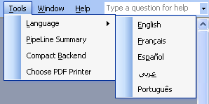
Figure A-18—Language options

- Click on the Language option.

The Language pop-up menu is displayed
(see Figure A-18).

- Click on the desired language.

PipeLine’s screens, buttons, etc., are displayed in the selected language until the current session is closed.

Accessing the Summary Module
The PipeLine Summary module (only available in English) is intended for program managers and/or consultants responsible for managing multiple programs tracked by PipeLine. It aggregates PipeLine data from selected programs, and arranges the data so it can be presented in a graph or report.

To access the PipeLine Summary Module—

- Click on the Tools Menu Bar option.

- Click on the PipeLine Summary option.

See Section 8, PipeLine Summary, for detailed information on the PipeLine Summary Module.

Compacting the PipeLine Database
PipeLine provides a function to compact the current program file, often referred to as compacting the backend. The Compact Backend option is useful if you use PipeLine on a laptop and are running out of disk space.

To compact the PipeLine database—

- Click on the Tools Menu Bar option.

- Click on the Compact Backend option.

PipeLine compacts the database and displays a confirmation message.

- Click on OK.

Choose PDF Printer
The Choose PDF Printer option enables you to define your PDF writer so you can create PDF PipeLine graphs and reports within the software (see Figure A-19).

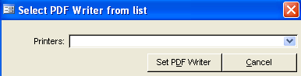
Figure A-19—Select PDF Writer from list To choose your PDF writer—

- Click on the Tools option of the Pipeline Menu Bar.

- Click on the Choose PDF Printer option in the pull-down menu.

A window is displayed, showing the printers available on your machine.

- Click on the arrow next to the Printers field, and select the PDF writer from the pull-down menu.

- Click on the Set PDF Writer button to set the printer.

PipeLine’s Help Utility
The PipeLine Help utility provides access to PipeLine’s online help system. It also provides access to PipeLine’s About feature. This feature lets you see what version of PipeLine you are running. Figure A-20 shows an example of the Help drop-down menu.
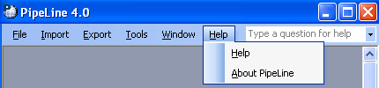
Figure A-20—Help options

PipeLine’s About Feature
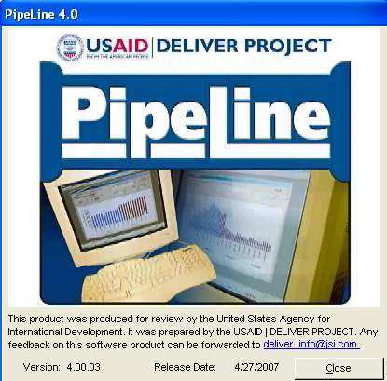
Figure A-21—PipeLine’s About window The About PipeLine option of the Help drop-down menu displays the PipeLine version you are using.

To view the version of PipeLine you are currently using—

- Click on the Help option on the PipeLine Menu Bar.

- Click on About PipeLine.

PipeLine displays the About window (see Figure A-21).

- Click on the Close button to close the About window.

